Streamlit Data Utility

Application Overview, Features & User Guide
1. Introduction
The Streamlit Data Utility is a Streamlit-based application designed to simplify data management, data movement, data quality validation, and AI-assisted data analysis within Snowflake.
The application provides a user-friendly interface for working with Snowflake tables and files stored in Azure Blob Storage. It allows users to select source and target datasets, preview data, perform copy operations, run data quality checks, and use Snowflake Cortex to analyze datasets using natural-language questions.
2. Key Features
Feature 1: Source and Target Selection
Users can select the source and target datasets through the application interface.
Supported sources:
- Snowflake tables.
- Files stored in Azure Blob Storage and accessed through a configured Snowflake external stage.
- CSV files and supported delimited TXT files, including pipe-delimited files.
Users can:
- Select the source database, schema, and table.
- Select an Azure Blob file from the configured external stage.
- Select the target database, schema, and table.
- Work with different source and target datasets without manually writing the copy SQL.
Feature 2: Source Data Editing
The application provides a data editing workspace for Snowflake table sources.
Users can:
- Select a source table.
- Load a configurable number of rows into the editing interface.
- Review and modify the selected data.
- Save changes back to the source database.
- Refresh the displayed source data.
Note: Direct editing of files in Azure Blob Storage is not supported. Azure files must first be loaded into a Snowflake table before users can edit the data through the table editing functionality.
Feature 3: Copy Data
The Copy Data workspace enables users to copy data between Snowflake datasets or load files from Azure Blob Storage into Snowflake tables.
Snowflake-to-Snowflake copy
Users can choose from the following operations:
Operation | Description
Copy Schema Only | Copies the selected source schema structure.
Copy Data Only | Copies data into an existing target table.
Copy Schema and Data | Copies the schema structure and data.

Users can also select how existing target data should be handled:
- APPEND: Adds the incoming data to the target table.
- REPLACE: Replaces the existing target data as part of the copy operation.
The application provides source data previews and target validation to help users review their selections before executing a copy.
Azure Blob-to-Snowflake copy
Users can:
- Select a file from the configured Azure Blob external stage.
- Preview the staged file.
- Review the generated COPY INTO SQL.
- Select the target Snowflake table.
- Choose the supported copy behavior.
- Confirm and execute the load.
The application supports CSV and configured delimited TXT files, including pipe-delimited data.
Important: The REPLACE operation can remove existing target data before loading the new data. Users should review the target and copy operation carefully before confirming.
Feature 4: Data Preview
The application allows users to preview source data before performing copy or analysis operations.
For Snowflake tables, users can inspect selected source records.
For Azure Blob files, users can preview the staged file contents through Snowflake.
This helps users verify that they have selected the intended dataset and that the data is being interpreted correctly before proceeding.
Feature 5: Data Quality Checks
The Data Quality Checks functionality helps users identify potential data quality issues in their datasets.
It is available for both Snowflake tables and supported Azure Blob CSV/TXT files.
Built-in checks
Check | Purpose
Row Count | Reports the number of rows in the selected dataset.
Null Values | Identifies null values by column.
Blank Strings | Identifies blank string values.
Negative Numbers | Identifies negative numeric values.
Duplicate Rows | Identifies duplicate records according to the check's implemented logic.
Invalid Dates | Identifies date values that fail the implemented validation.

Users can select the checks they want to run.
Custom SQL quality checks
Users can also enter their own read-only SQL quality queries using the custom SQL interface.
The application validates the query before execution. For staged-file checks, the query is restricted to the selected staged file.
Results
The application displays quality-check results in tabular form, including:
- Check type.
- Column name, where applicable.
- Issue count.
For CSV files with headers, the application uses the inferred header names in the results rather than positional labels such as C1, C2, and C3.
Purpose: These checks help users identify potential data issues before copying, transforming, or analyzing the data. They do not automatically correct the underlying data.
Feature 6: AI-Powered Data Analysis Using Snowflake Cortex
The application integrates Snowflake Cortex to support AI-assisted analysis.
Users can submit questions in natural language rather than manually constructing every analytical SQL query.
The application generates and validates read-only SQL internally before executing the analysis.
A. Single Table Analysis
Users can select a table and ask questions about its contents.
The results are displayed in the application, with an AI-generated explanation where available.
B. Cross Table Analysis
Users can select multiple tables and ask questions that require information from across those datasets.
This can help users explore relationships between datasets without manually writing all the required SQL.
The questions should be aligned with the tables and relationships available in the selected datasets.
C. Fraud & Waste Analysis
The application includes healthcare-focused analysis scenarios intended to identify potentially anomalous or suspicious claim patterns.
Users can select a predefined scenario or enter a custom question.
Important: The results are intended to support investigation and review. A detected anomaly is not, by itself, proof of fraud or improper billing.

D. Customer Sentiment Analysis
Users can analyze customer feedback and sentiment-related datasets.
The functionality supports questions about customer sentiment and feedback patterns.
The results can help users explore feedback and identify themes for further review.
E. Azure Blob CSV/TXT Analysis
Users can also perform Cortex analysis directly against supported files stored in Azure Blob Storage.
The application uses the configured Snowflake external stage to access the files.
Supported file types include CSV and configured delimited TXT files, such as pipe-delimited data.
Users can ask natural-language questions about the selected file, and the application uses inferred column information to support the analysis.
Feature 7: Analysis Results and Visualization
The application displays analysis results in the Streamlit interface.
Depending on the analysis and available output, users can:
- Review query results in a table.
- Read the AI-generated explanation.
- Use the available visualization controls to explore analytical results.
- Select chart types and fields where supported.
These capabilities help users interpret results and communicate findings more easily.

3. Typical User Workflow
A typical workflow using the application is:
Step 1 — Select the source
Choose a Snowflake table or an Azure Blob file.
Step 2 — Select the target, if performing a copy
Choose the destination database, schema, and table.
Step 3 — Preview the data
Review the source records or staged file contents.
Step 5 — Perform the required operation
Depending on the use case:
- Edit source table data.
- Copy data or schema.
- Load an Azure Blob file into Snowflake.
- Run AI-assisted data analysis.
Step 6 — Review the results
Inspect the copy status, quality-check results, analysis output, and available explanations or visualizations.
Step 7 — Validate data quality
Run the required built-in checks or a custom read-only SQL quality query.

4. Technology and Processing Overview
The application uses the following technologies:
Technology | Role
Streamlit | Provides the interactive application interface.
Snowflake | Provides data storage, SQL execution, data loading, and analytical processing.
Snowflake Cortex | Supports AI-assisted SQL generation and data analysis.
Snowflake External Stage | Provides access to files stored in Azure Blob Storage.
Azure Blob Storage | Stores source files such as CSV and delimited TXT datasets.
Snowpark Python | Supports application interaction with Snowflake.

For Azure Blob sources, the application accesses files through Snowflake's external stage. Data loading, copy operations, and analysis execute in Snowflake; the application does not need to download the source file into Streamlit.
5. Benefits for Users
The utility is designed to help users:
- Reduce manual SQL effort through a guided interface for common data operations.
- Simplify data movement between Snowflake tables and from Azure Blob Storage into Snowflake.
- Review data before loading through source previews and generated SQL previews.
- Identify potential data quality issues using built-in checks and custom read-only SQL.
- Explore data using natural language with Snowflake Cortex.
- Support healthcare analytics demonstrations involving Mediclaim Fraud & Waste and Customer Sentiment Analysis.
- Explore analytical results through tables, explanations, and available visualization controls.
6. Important Usage Considerations
- Users should verify the selected source and target before executing copy operations.
- The REPLACE option may remove existing target data; it should be used only after reviewing the operation.
- Direct editing of Azure Blob files is not supported. Files must first be loaded into Snowflake.
- Data Quality Checks identify potential issues; they do not automatically remediate the data.
- Cortex-generated analysis should be reviewed in the context of the selected datasets and business rules.
- Fraud and waste findings are indicators for further investigation, not definitive determinations.
- Access to databases, tables, stages, file formats, and Cortex functionality depends on the permissions and configuration of the Snowflake environment.
7. Summary
The Streamlit Data Utility brings together data selection, editing, copying, quality validation, and AI-assisted analysis in a single Streamlit application.
It supports Snowflake tables and Azure Blob CSV/TXT files, allowing users to preview and move data, identify potential quality issues, and explore datasets using Snowflake Cortex.
By combining guided data operations with analytical capabilities, the application provides a common workspace for data management and healthcare analytics demonstrations, including Mediclaim Fraud & Waste Analysis and Customer Sentiment Analysis.

Use Cases
1. Generate sql query and can use it to update values in a columns of a table in snowflake
2. Copy data, Copy Schema, Copy data & schema
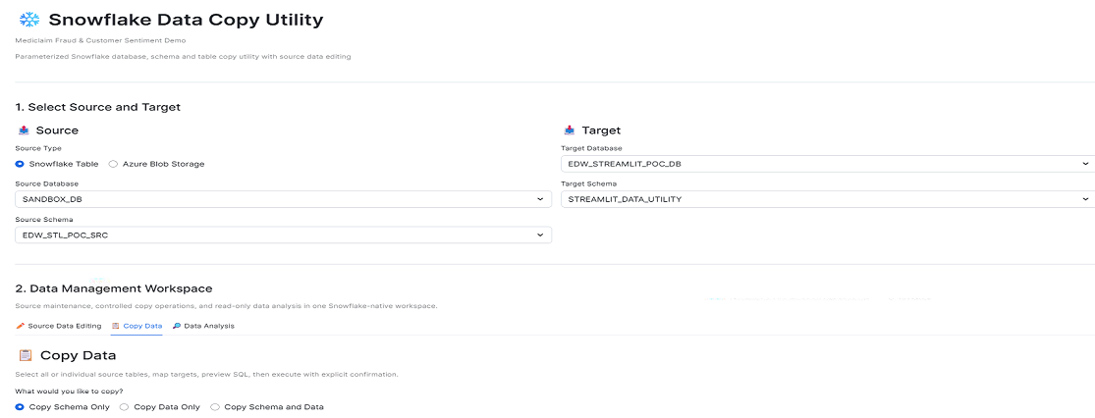

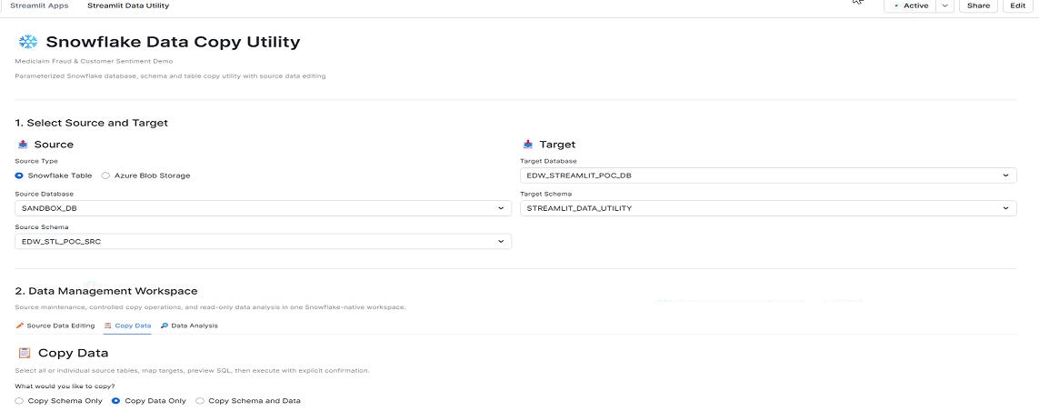
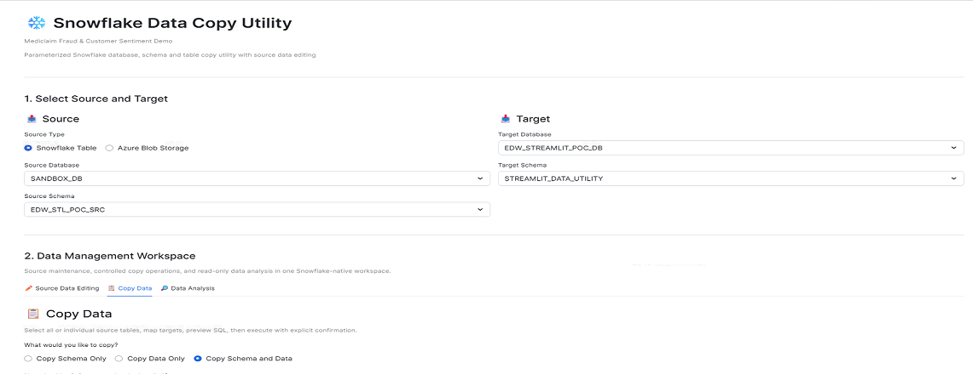

3. Data analysis - single table, cross table, data quality checks

